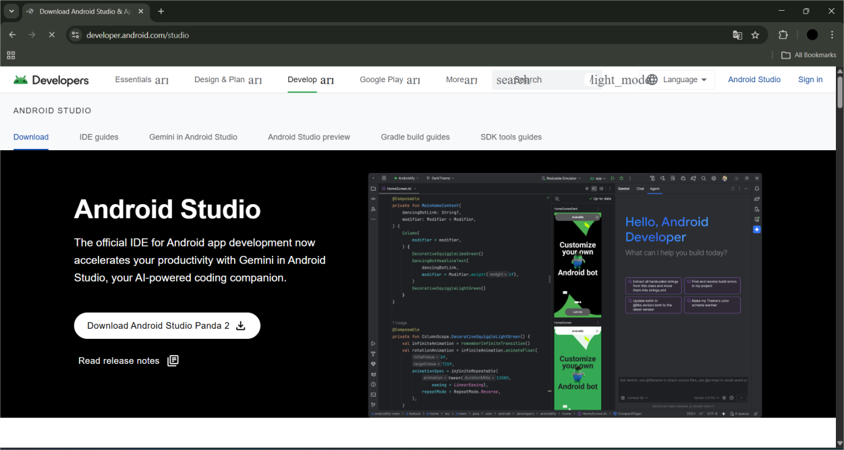
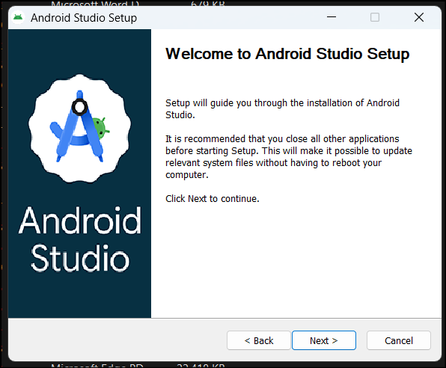
Experiment No. 1 Title: Installation of Android SDK, emulator.

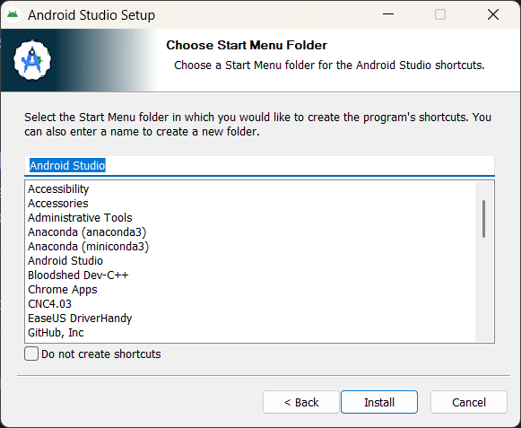
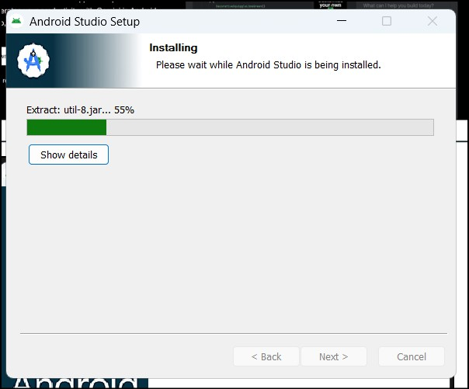

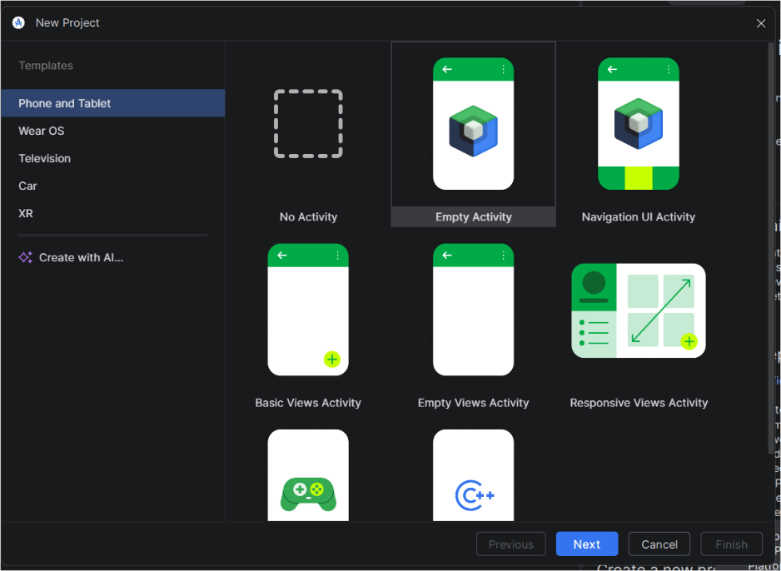

Experiment No. 2
Title: To create a simple Android application, study the Android project structure, configure a mobile device in Android Studio, and install the APK on a mobile device/tablet.
Program:
Activity_main.xml
<?xml version="1.0" encoding="utf-8"?>
<LinearLayout xmlns:android="http://schemas.android.com/apk/res/android" android:layout_width="match_parent" android:layout_height="match_parent" android:gravity="center"
android:orientation="vertical" android:padding="20dp">

<TextView android:layout_width="wrap_content" android:layout_height="wrap_content" android:text="Simple Android App" android:textSize="22sp" android:textStyle="bold" android:layout_marginBottom="20dp"/>

<EditText android:id="@+id/editTextName" android:layout_width="match_parent" android:layout_height="wrap_content" android:hint="Enter your name" android:padding="10dp"/>

<Button
android:id="@+id/buttonSubmit" android:layout_width="wrap_content" android:layout_height="wrap_content" android:text="Submit" android:layout_marginTop="15dp"/>

<TextView android:id="@+id/textViewResult" android:layout_width="wrap_content" android:layout_height="wrap_content" android:text="" android:textSize="20sp" android:layout_marginTop="20dp"/>

</LinearLayout> MainActivity.java :
package com.example.myfirstapplication;

import android.os.Bundle; import android.view.View; import android.widget.Button; import android.widget.EditText; import android.widget.TextView;
import androidx.appcompat.app.AppCompatActivity; public class MainActivity extends AppCompatActivity {
EditText editTextName; Button buttonSubmit; TextView textViewResult;

@Override
protected void onCreate(Bundle savedInstanceState) { super.onCreate(savedInstanceState); setContentView(R.layout.activity_main);
editTextName = findViewById(R.id.editTextName);

buttonSubmit = findViewById(R.id.buttonSubmit); textViewResult = findViewById(R.id.textViewResult);

buttonSubmit.setOnClickListener(new View.OnClickListener() { @Override
public void onClick(View v) {
String name = editTextName.getText().toString(); if(name.isEmpty()) {
textViewResult.setText("Please enter your name");
} else {
textViewResult.setText("Hello " + name);
}
}
});
}
}

Output:
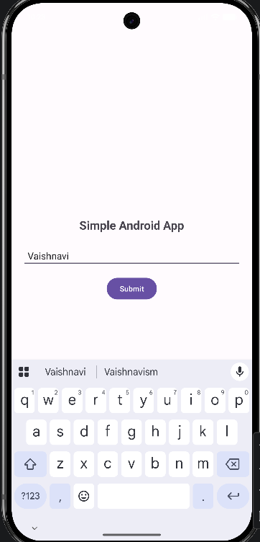
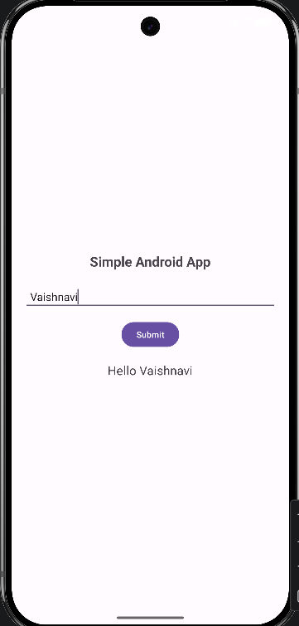

Experiment No. 3
Title : Write a program to use of different layouts: Linear, Relative, Frame layout, Table Layout

Linear Layout :
MainActivity.java :
package com.example.layoutdemoapplication; import android.os.Bundle;
import androidx.appcompat.app.AppCompatActivity;

public class MainActivity extends AppCompatActivity { @Override
protected void onCreate(Bundle savedInstanceState) { super.onCreate(savedInstanceState);
// Change layout here to test setContentView(R.layout.activity_linear);
}
}

Activity_linear.xml:
<?xml version="1.0" encoding="utf-8"?>
<LinearLayout xmlns:android="http://schemas.android.com/apk/res/android" android:layout_width="match_parent" android:layout_height="match_parent" android:orientation="vertical"
android:padding="20dp" android:background="#F5F5F5">

<TextView android:layout_width="wrap_content" android:layout_height="wrap_content" android:text="Linear Layout" android:textSize="24sp" android:textStyle="bold" android:layout_marginBottom="20dp"/>

<EditText android:hint="Enter Name"
android:layout_width="match_parent" android:layout_height="wrap_content" android:background="@android:drawable/edit_text" android:padding="10dp"/>

<Button
android:text="Submit" android:layout_width="match_parent" android:layout_height="wrap_content" android:layout_marginTop="15dp"/>

</LinearLayout>

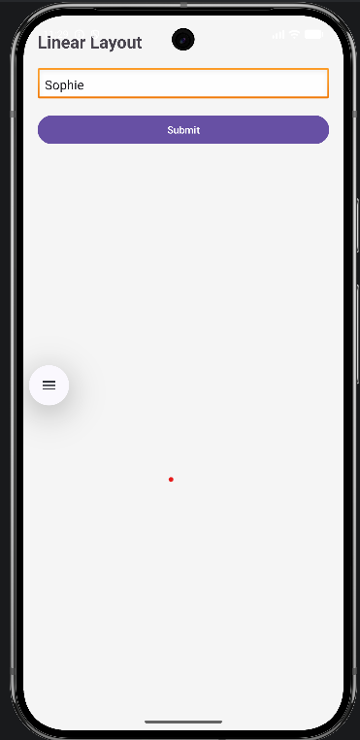
Output :

Relative Layout :
MainActivity.java :
package com.example.layoutdemoapplication;

import android.os.Bundle;
import androidx.appcompat.app.AppCompatActivity;

public class MainActivity extends AppCompatActivity { @Override
protected void onCreate(Bundle savedInstanceState) { super.onCreate(savedInstanceState);
// Change layout here to test setContentView(R.layout.activity_relative);
}
}

Activity_relative.xml
<?xml version="1.0" encoding="utf-8"?>
<RelativeLayout xmlns:android="http://schemas.android.com/apk/res/android" android:layout_width="match_parent" android:layout_height="match_parent" android:background="#E3F2FD">

<TextView android:id="@+id/title" android:text="Login Form" android:textSize="24sp" android:textStyle="bold"
android:layout_centerHorizontal="true" android:layout_marginTop="50dp"

android:layout_width="wrap_content" android:layout_height="wrap_content"/>

<EditText android:hint="Username"
android:layout_below="@id/title" android:layout_marginTop="20dp" android:layout_width="match_parent" android:layout_height="wrap_content" android:layout_marginLeft="20dp" android:layout_marginRight="20dp"/>

<Button
android:text="Login" android:layout_below="@id/title" android:layout_centerHorizontal="true" android:layout_marginTop="100dp" android:layout_width="wrap_content" android:layout_height="wrap_content"/>

</RelativeLayout>

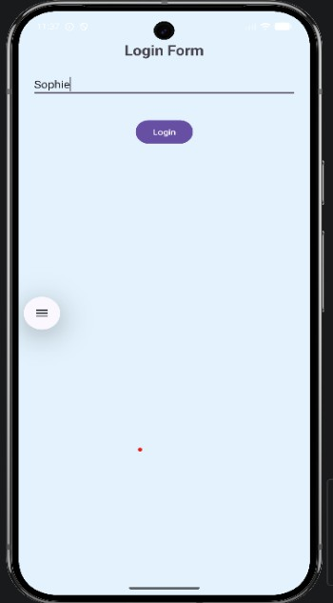
Output :

Frame Layout :
MainActivity.java
package com.example.layoutdemoapplication;

import android.os.Bundle;
import androidx.appcompat.app.AppCompatActivity;

public class MainActivity extends AppCompatActivity { @Override
protected void onCreate(Bundle savedInstanceState) { super.onCreate(savedInstanceState);
// Change layout here to test setContentView(R.layout.activity_frame);
}

}
Activity_frame.xml
<?xml version="1.0" encoding="utf-8"?>
<FrameLayout xmlns:android="http://schemas.android.com/apk/res/android" android:layout_width="match_parent" android:layout_height="match_parent" android:background="#EDE7F6">

<!-- Background Text -->
<TextView android:layout_width="wrap_content" android:layout_height="wrap_content" android:text="Frame Layout Demo" android:textSize="24sp" android:textStyle="bold" android:layout_gravity="top|center_horizontal" android:layout_marginTop="40dp"/>

<!-- Center Card -->
<LinearLayout android:layout_width="300dp" android:layout_height="wrap_content" android:orientation="vertical" android:background="#FFFFFF" android:padding="20dp" android:elevation="6dp" android:layout_gravity="center">

<TextView android:text="Login" android:textSize="20sp" android:textStyle="bold"
android:layout_marginBottom="10dp" android:layout_width="wrap_content" android:layout_height="wrap_content"/>

<EditText android:hint="Username"
android:layout_width="match_parent" android:layout_height="wrap_content"/>

<EditText android:hint="Password"
android:layout_width="match_parent" android:layout_height="wrap_content" android:layout_marginTop="10dp"/>

<Button
android:text="Submit" android:layout_width="match_parent"

android:layout_height="wrap_content" android:layout_marginTop="15dp"/>
</LinearLayout>

<!-- Bottom Button -->
<Button
android:text="Help" android:layout_width="wrap_content" android:layout_height="wrap_content" android:layout_gravity="bottom|center_horizontal" android:layout_marginBottom="30dp"/>

</FrameLayout>

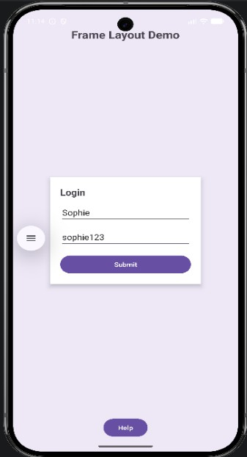
Output :

Table Layout :
MainActivity.java :
package com.example.layoutdemoapplication;

import android.os.Bundle;
import androidx.appcompat.app.AppCompatActivity;

public class MainActivity extends AppCompatActivity { @Override
protected void onCreate(Bundle savedInstanceState) { super.onCreate(savedInstanceState);
// Change layout here to test setContentView(R.layout.activity_table);
}
}
Activity_table.xml :
<?xml version="1.0" encoding="utf-8"?>
<TableLayout xmlns:android="http://schemas.android.com/apk/res/android" android:layout_width="match_parent" android:layout_height="match_parent" android:padding="20dp"
android:background="#FFF3E0">

<TableRow>
<TextView android:text="Name" android:textStyle="bold" android:padding="10dp"/>
<EditText
android:hint="Enter Name"/>
</TableRow>

<TableRow>
<TextView android:text="Email" android:textStyle="bold" android:padding="10dp"/>
<EditText
android:hint="Enter Email"/>
</TableRow>

<TableRow>
<Button
android:text="Register" android:layout_span="2" android:layout_marginTop="20dp"/>
</TableRow>

</TableLayout>

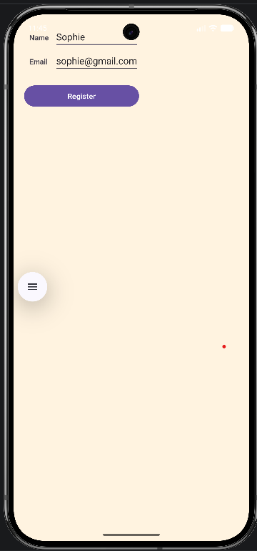
Output :

Experiment No. 4
Title : Write a program to study Intents for switching between activities. Program :

Activity_main.xml :
<?xml version="1.0" encoding="utf-8"?>
<LinearLayout xmlns:android="http://schemas.android.com/apk/res/android" android:layout_width="match_parent" android:layout_height="match_parent" android:gravity="center"
android:orientation="vertical">

<TextView
android:text="First Activity" android:textSize="22sp" android:layout_marginBottom="20dp" android:layout_width="wrap_content" android:layout_height="wrap_content"/>

<Button
android:id="@+id/btnNext" android:text="Go to Second Activity" android:layout_width="wrap_content" android:layout_height="wrap_content"/>
</LinearLayout> MainActivity.java :
package com.example.intentswitchingapplication;

import android.content.Intent; import android.os.Bundle; import android.widget.Button;
import androidx.appcompat.app.AppCompatActivity;

public class MainActivity extends AppCompatActivity { Button btnNext;
@Override
protected void onCreate(Bundle savedInstanceState) { super.onCreate(savedInstanceState); setContentView(R.layout.activity_main);
btnNext = findViewById(R.id.btnNext); btnNext.setOnClickListener(v -> {
Intent intent = new Intent(MainActivity.this, SecondActivity.class); startActivity(intent);
});
}
}
Activity_second.xml :
<?xml version="1.0" encoding="utf-8"?>

<LinearLayout xmlns:android="http://schemas.android.com/apk/res/android" android:layout_width="match_parent" android:layout_height="match_parent" android:gravity="center"
android:orientation="vertical">

<TextView
android:text="Second Activity" android:textSize="22sp" android:layout_marginBottom="20dp" android:layout_width="wrap_content" android:layout_height="wrap_content"/>

</LinearLayout> SecondActivity.java :
package com.example.intentswitchingapplication;

import android.os.Bundle;
import androidx.appcompat.app.AppCompatActivity;

public class SecondActivity extends AppCompatActivity { @Override
protected void onCreate(Bundle savedInstanceState) { super.onCreate(savedInstanceState); setContentView(R.layout.activity_second);
}
}

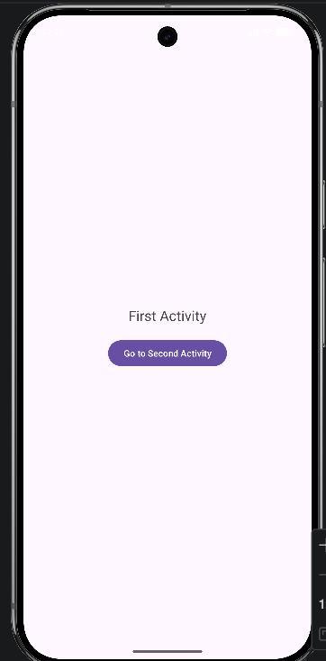
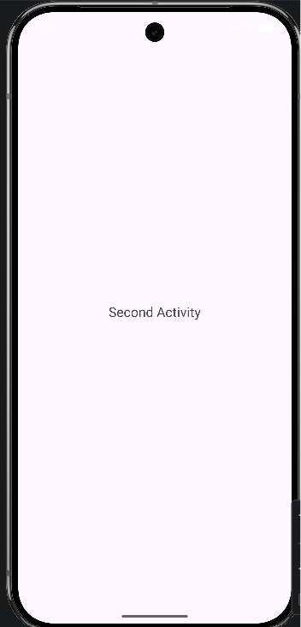
Output :

Experiment No. 5
Title : Write a program to study Intents for Telephony services

Program :

Activity_main.xml :
<?xml version="1.0" encoding="utf-8"?>
<LinearLayout xmlns:android="http://schemas.android.com/apk/res/android" android:layout_width="match_parent" android:layout_height="match_parent" android:orientation="vertical"
android:gravity="center" android:padding="20dp">

<EditText android:id="@+id/editNumber" android:layout_width="match_parent" android:layout_height="wrap_content" android:hint="Enter Phone Number"/>

<Button
android:id="@+id/btnDial" android:layout_width="match_parent" android:layout_height="wrap_content" android:text="Dial Number" android:layout_marginTop="10dp"/>

<Button
android:id="@+id/btnSms" android:layout_width="match_parent" android:layout_height="wrap_content" android:text="Send SMS" android:layout_marginTop="10dp"/>

</LinearLayout> MainActivity.java :
package com.example.intentstelephonyservices;

import android.content.Intent; import android.net.Uri; import android.os.Bundle; import android.widget.Button;
import android.widget.EditText;
import androidx.appcompat.app.AppCompatActivity;

public class MainActivity extends AppCompatActivity { EditText editNumber;
Button btnDial, btnSms; @Override
protected void onCreate(Bundle savedInstanceState) { super.onCreate(savedInstanceState);

setContentView(R.layout.activity_main); editNumber = findViewById(R.id.editNumber); btnDial = findViewById(R.id.btnDial);
btnSms = findViewById(R.id.btnSms);

// Dial Number (Safe) btnDial.setOnClickListener(v -> {
String number = editNumber.getText().toString(); Intent intent = new Intent(Intent.ACTION_DIAL); intent.setData(Uri.parse("tel:" + number)); startActivity(intent);
});

// Send SMS btnSms.setOnClickListener(v -> {
String number = editNumber.getText().toString(); Intent intent = new Intent(Intent.ACTION_VIEW); intent.setData(Uri.parse("sms:" + number));
intent.putExtra("sms_body", "Hello from Android App"); startActivity(intent);
});
}
}
AndroidManifest.xml :
<?xml version="1.0" encoding="utf-8"?>
<manifest xmlns:android="http://schemas.android.com/apk/res/android">
<application android:allowBackup="true" android:label="@string/app_name"
android:theme="@style/Theme.AppCompat.Light.DarkActionBar">
<activity android:name=".MainActivity" android:exported="true">
<intent-filter>
<action android:name="android.intent.action.MAIN"/>
<category android:name="android.intent.category.LAUNCHER"/>
</intent-filter>
</activity>
</application>
</manifest>

Output :

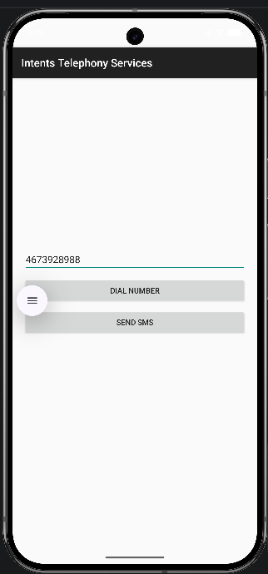
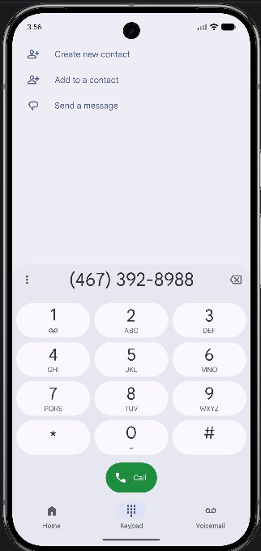
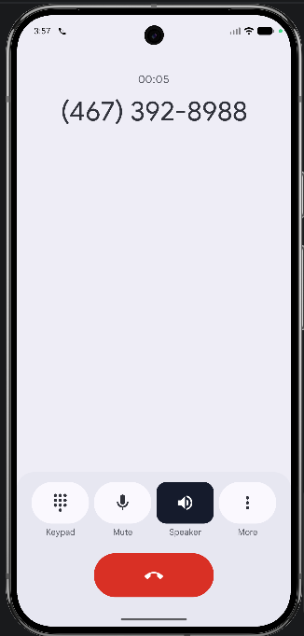

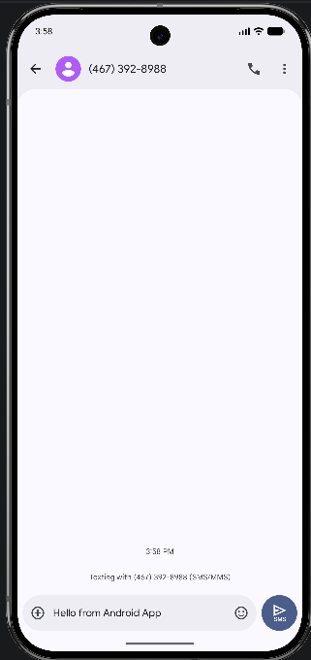
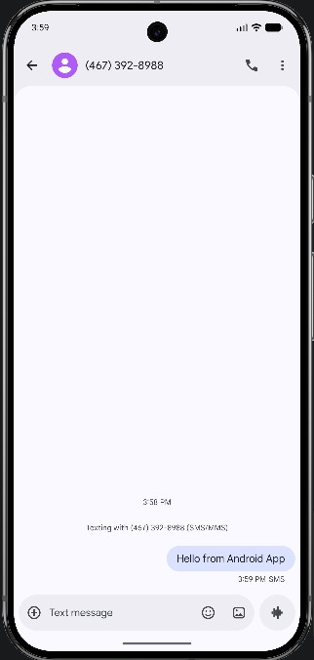

Experiment No. 6 Title : Write a program to study Intents for SMS and Email Program :

Activity_main.xml :
<?xml version="1.0" encoding="utf-8"?>
<androidx.constraintlayout.widget.ConstraintLayout xmlns:android="http://schemas.android.com/apk/res/android"
xmlns:app="http://schemas.android.com/apk/res-auto" xmlns:tools="http://schemas.android.com/tools" android:layout_width="match_parent" android:layout_height="match_parent" tools:context=".MainActivity">

<TextView android:id="@+id/tvTitle"
android:layout_width="wrap_content" android:layout_height="wrap_content" android:text="Login" android:textSize="24sp" android:textStyle="bold" app:layout_constraintTop_toTopOf="parent" app:layout_constraintStart_toStartOf="parent" app:layout_constraintEnd_toEndOf="parent" android:layout_marginTop="40dp"/>

<EditText android:id="@+id/etEmail" android:layout_width="0dp"
android:layout_height="wrap_content" android:hint="Email" android:inputType="textEmailAddress" app:layout_constraintTop_toBottomOf="@id/tvTitle" app:layout_constraintStart_toStartOf="parent" app:layout_constraintEnd_toEndOf="parent" android:layout_margin="24dp"/>

<EditText android:id="@+id/etPassword" android:layout_width="0dp" android:layout_height="wrap_content" android:hint="Password" android:inputType="textPassword"
app:layout_constraintTop_toBottomOf="@id/etEmail" app:layout_constraintStart_toStartOf="parent" app:layout_constraintEnd_toEndOf="parent" android:layout_margin="24dp"/>

<Button
android:id="@+id/btnLogin"

android:layout_width="wrap_content" android:layout_height="wrap_content" android:text="Login" app:layout_constraintTop_toBottomOf="@id/etPassword" app:layout_constraintStart_toStartOf="parent" app:layout_constraintEnd_toEndOf="parent" android:layout_marginTop="24dp"/>

</androidx.constraintlayout.widget.ConstraintLayout>

Activity_second.xml :
<?xml version="1.0" encoding="utf-8"?>
<androidx.constraintlayout.widget.ConstraintLayout xmlns:android="http://schemas.android.com/apk/res/android"
xmlns:app="http://schemas.android.com/apk/res-auto" xmlns:tools="http://schemas.android.com/tools" android:layout_width="match_parent" android:layout_height="match_parent" tools:context=".SecondActivity">

<TextView android:id="@+id/tvSuccess" android:layout_width="wrap_content" android:layout_height="wrap_content" android:text="Logged in successfully" android:textSize="20sp" android:textStyle="bold"
app:layout_constraintTop_toTopOf="parent" app:layout_constraintBottom_toBottomOf="parent" app:layout_constraintStart_toStartOf="parent" app:layout_constraintEnd_toEndOf="parent" />

</androidx.constraintlayout.widget.ConstraintLayout>

MainActivity.java :
package com.example.intentexperiment;

import android.content.Intent; import android.os.Bundle; import android.view.View; import android.widget.Button; import android.widget.EditText; import android.widget.Toast;
import androidx.appcompat.app.AppCompatActivity;

public class MainActivity extends AppCompatActivity { EditText etEmail, etPassword;
Button btnLogin; @Override
protected void onCreate(Bundle savedInstanceState) { super.onCreate(savedInstanceState);

setContentView(R.layout.activity_main); etEmail = findViewById(R.id.etEmail); etPassword = findViewById(R.id.etPassword); btnLogin = findViewById(R.id.btnLogin);
btnLogin.setOnClickListener(new View.OnClickListener() { @Override
public void onClick(View v) {
String email = etEmail.getText().toString().trim();
String password = etPassword.getText().toString().trim(); if (email.isEmpty() || password.isEmpty()) {
Toast.makeText(MainActivity.this, "Please enter email and password", Toast.LENGTH_SHORT).show();
} else {
Intent intent = new Intent(MainActivity.this, SecondActivity.class); intent.putExtra("userEmail", email);
startActivity(intent);
}
}
});
}
}

SecondActiity.java :
package com.example.intentexperiment;

import android.os.Bundle; import android.widget.Toast;
import androidx.appcompat.app.AppCompatActivity;

public class SecondActivity extends AppCompatActivity { @Override
protected void onCreate(Bundle savedInstanceState) { super.onCreate(savedInstanceState); setContentView(R.layout.activity_second);
String email = getIntent().getStringExtra("userEmail"); if (email != null) {
Toast.makeText(this, "Welcome " + email,
Toast.LENGTH_LONG).show();
}
}
}

Output :

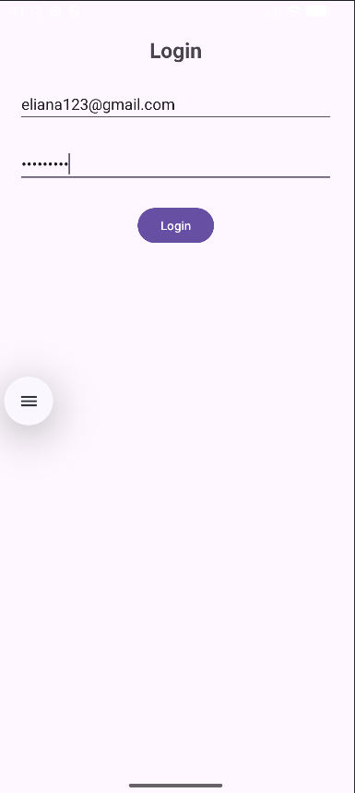


Experiment No .7 Title : Write a program to study and demonstrate Broadcast Receiver Program :

activity_main.xml :
<?xml version="1.0" encoding="utf-8"?>
<LinearLayout xmlns:android="http://schemas.android.com/apk/res/android" android:orientation="vertical"
android:padding="20dp" android:layout_width="match_parent" android:layout_height="match_parent">

<TextView android:text="Aeroplane Mode" android:textSize="22sp"
android:layout_width="wrap_content" android:layout_height="wrap_content"/>

<Switch android:id="@+id/switchAirplane"
android:text="Turn On/Off Aeroplane Mode" android:layout_width="wrap_content" android:layout_height="wrap_content"/>

<Button
android:id="@+id/btnCheck" android:text="Check Status" android:layout_width="wrap_content" android:layout_height="wrap_content"/>

</LinearLayout>

MainActivity.java :

package com.example.myapp_aeroplanemode;

import androidx.appcompat.app.AppCompatActivity; import android.os.Bundle;
import android.view.View; import android.widget.Button; import android.widget.Switch; import android.widget.Toast;

public class MainActivity extends AppCompatActivity { Switch switchAirplane;
Button btnCheck; @Override
protected void onCreate(Bundle savedInstanceState) { super.onCreate(savedInstanceState); setContentView(R.layout.activity_main);

switchAirplane = findViewById(R.id.switchAirplane); btnCheck = findViewById(R.id.btnCheck); btnCheck.setOnClickListener(new View.OnClickListener() {
@Override
public void onClick(View v) {
if (switchAirplane.isChecked()) { Toast.makeText(MainActivity.this,
"Aeroplane Mode ON", Toast.LENGTH_SHORT).show();
} else {
Toast.makeText(MainActivity.this, "Aeroplane Mode OFF", Toast.LENGTH_SHORT).show();
}
}
});
}
}

Output :

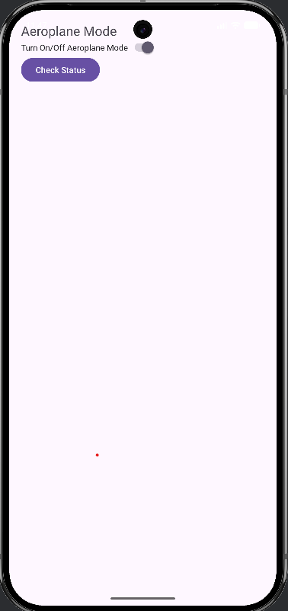
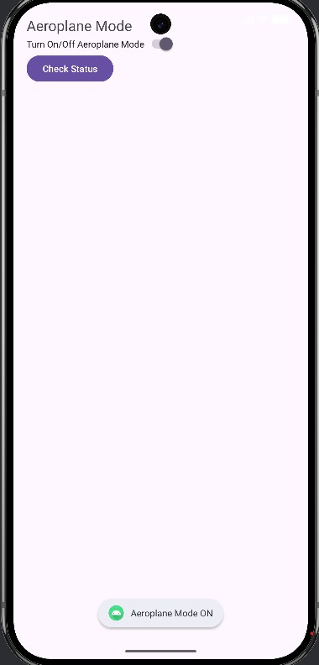

Experiment No: 08

Title: write a program to demonstrate buttons, text fields, checkboxes, radio buttons, spinners and toast with their event handlers.
activity_main.xml :

<?xml version="1.0" encoding="utf-8"?>
<ScrollView xmlns:android="http://schemas.android.com/apk/res/android" android:layout_width="match_parent" android:layout_height="match_parent">
<LinearLayout android:layout_width="match_parent" android:layout_height="wrap_content" android:orientation="vertical" android:padding="20dp">
<EditText android:id="@+id/editName"
android:layout_width="match_parent" android:layout_height="wrap_content" android:hint="Enter Name"/>
<TextView android:layout_width="wrap_content" android:layout_height="wrap_content" android:text="Select Hobbies" android:textStyle="bold" android:layout_marginTop="15dp"/>
<CheckBox android:id="@+id/checkReading" android:layout_width="wrap_content" android:layout_height="wrap_content" android:text="Reading"/>
<CheckBox android:id="@+id/checkSports" android:layout_width="wrap_content" android:layout_height="wrap_content" android:text="Sports"/>
<TextView android:layout_width="wrap_content" android:layout_height="wrap_content" android:text="Select Gender" android:textStyle="bold" android:layout_marginTop="15dp"/>
<RadioGroup android:id="@+id/radioGroup" android:layout_width="match_parent" android:layout_height="wrap_content">
<RadioButton
android:id="@+id/radioMale" android:layout_width="wrap_content" android:layout_height="wrap_content" android:text="Male"/>
<RadioButton

android:id="@+id/radioFemale" android:layout_width="wrap_content" android:layout_height="wrap_content" android:text="Female"/>
</RadioGroup>
<Spinner android:id="@+id/spinnerCountry" android:layout_width="match_parent" android:layout_height="wrap_content" android:layout_marginTop="15dp"/>
<Button
android:id="@+id/buttonSubmit" android:layout_width="match_parent" android:layout_height="wrap_content" android:text="Submit" android:layout_marginTop="20dp"/>
</LinearLayout>
</ScrollView>

MainActivity.java :

package com.example.uicomponentdemo; import android.os.Bundle;
import android.widget.*;
import androidx.appcompat.app.AppCompatActivity; public class MainActivity extends AppCompatActivity {
EditText editName;
CheckBox checkReading, checkSports; RadioGroup radioGroup;
Spinner spinnerCountry; Button buttonSubmit; @Override
protected void onCreate(Bundle savedInstanceState) { super.onCreate(savedInstanceState); setContentView(R.layout.activity_main);
// Bind views safely
editName = findViewById(R.id.editName); checkReading = findViewById(R.id.checkReading); checkSports = findViewById(R.id.checkSports); radioGroup = findViewById(R.id.radioGroup); spinnerCountry = findViewById(R.id.spinnerCountry); buttonSubmit = findViewById(R.id.buttonSubmit);
// 🚨 IMPORTANT: Check null (debug safety) if (editName == null || buttonSubmit == null) {
Toast.makeText(this, "View binding error!", Toast.LENGTH_LONG).show(); return;
}
// Spinner setup
String[] countries = {"India", "USA", "UK", "Canada"};
ArrayAdapter<String> adapter = new ArrayAdapter<>(this, android.R.layout.simple_spinner_item, countries);
adapter.setDropDownViewResource(android.R.layout.simple_spinner_dropdown_item); spinnerCountry.setAdapter(adapter);
// Button click buttonSubmit.setOnClickListener(v -> {

String name = editName.getText().toString().trim(); if (name.isEmpty()) {
Toast.makeText(this, "Enter your name!", Toast.LENGTH_SHORT).show(); return;
}
// Hobbies
String hobbies = "";
if (checkReading.isChecked()) hobbies += "Reading "; if (checkSports.isChecked()) hobbies += "Sports ";
// Gender
String gender = "Not Selected";
int selectedId = radioGroup.getCheckedRadioButtonId(); if (selectedId != -1) {
RadioButton rb = findViewById(selectedId); if (rb != null) {
gender = rb.getText().toString();
}
}
// Country
String country = spinnerCountry.getSelectedItem().toString();
// Result
String result = "Name: " + name + "\nHobbies: " + hobbies + "\nGender: " + gender + "\nCountry: " + country;
Toast.makeText(MainActivity.this, result, Toast.LENGTH_LONG).show();
});
}
}

Output :

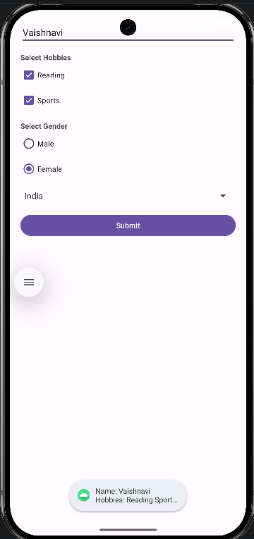

Experiment No: 09

Title: Write a program to demonstrate dialog-TimePicker, DatePicker, Alert with their events handler.
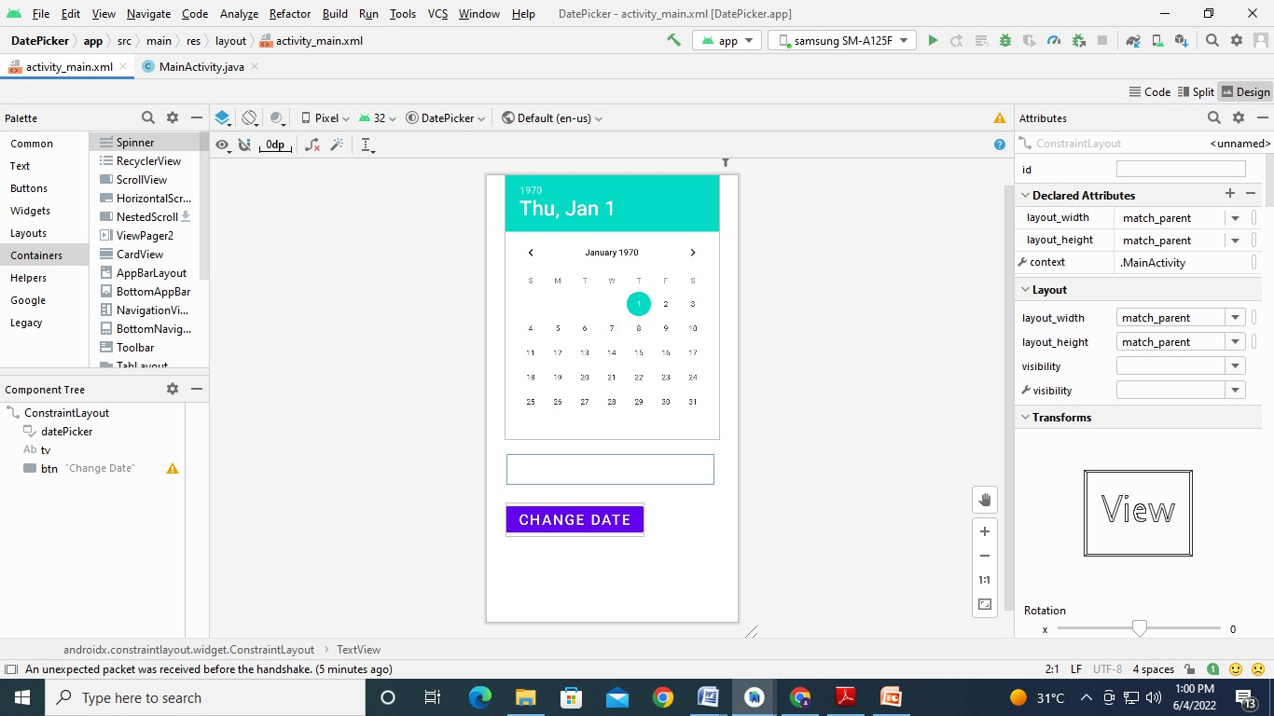
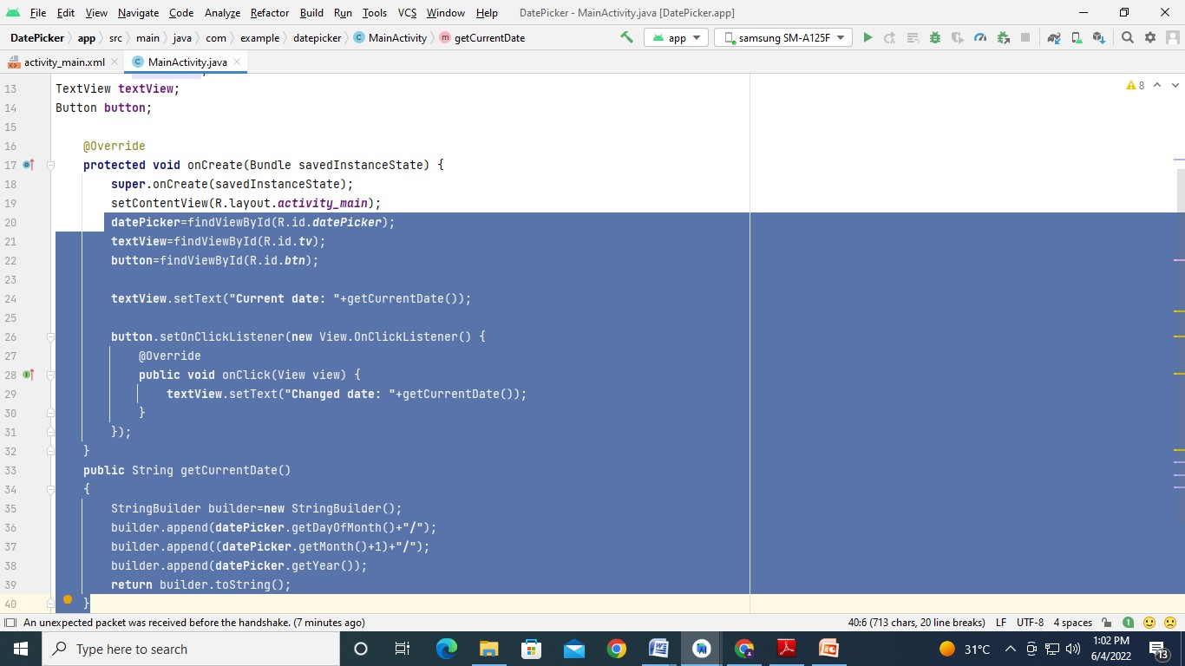

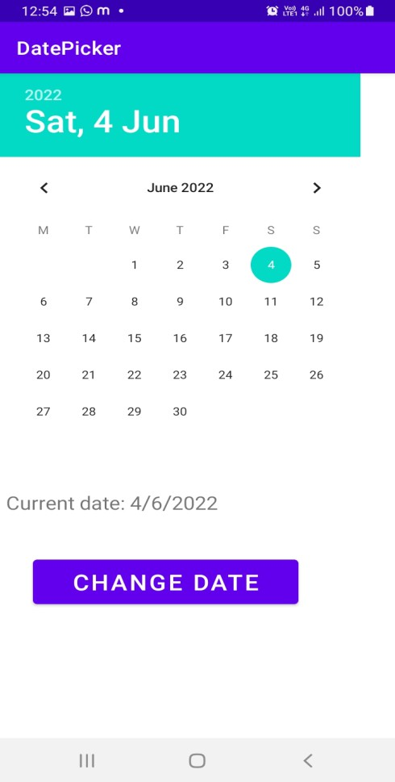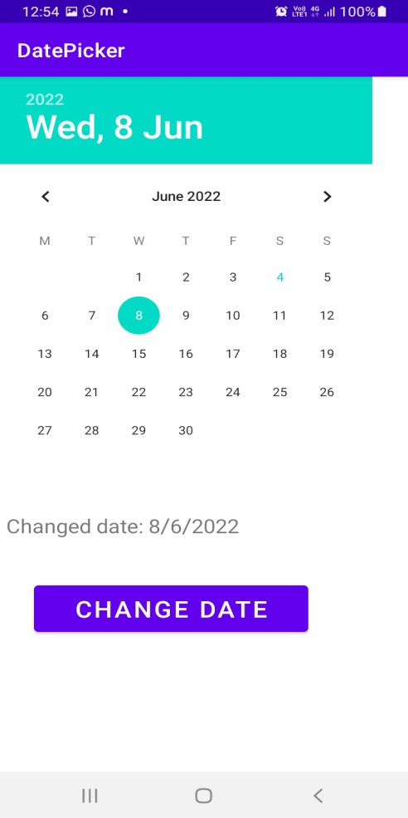

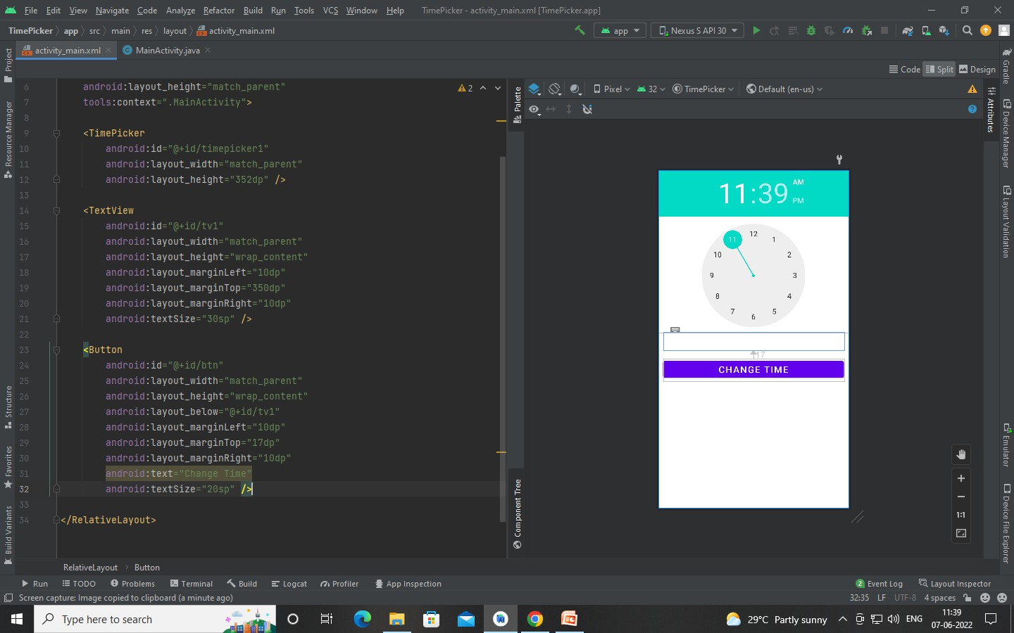

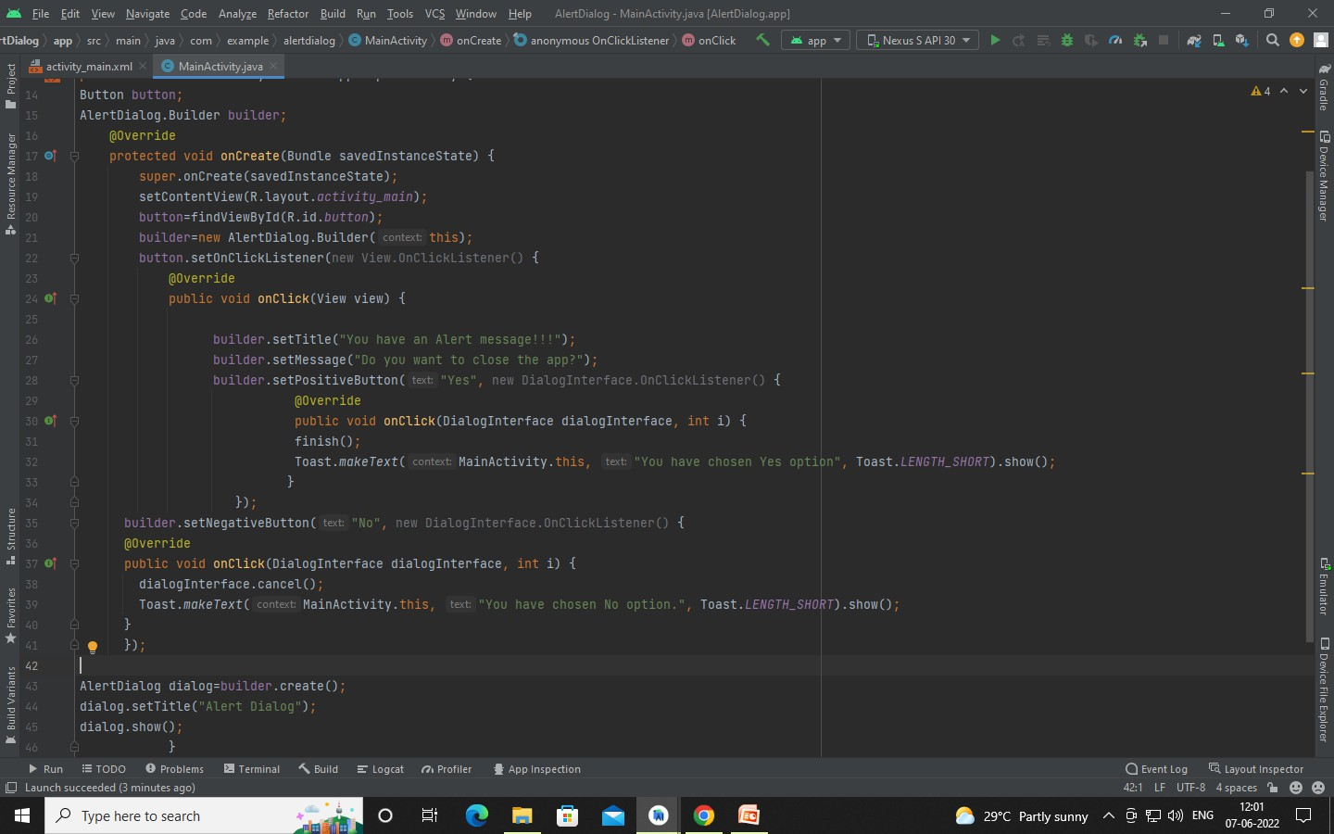

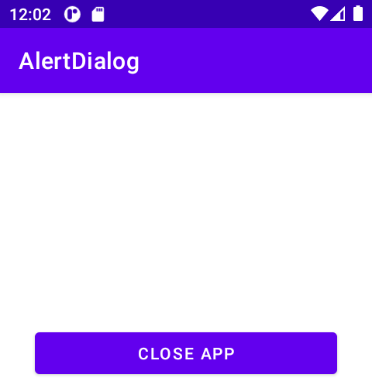
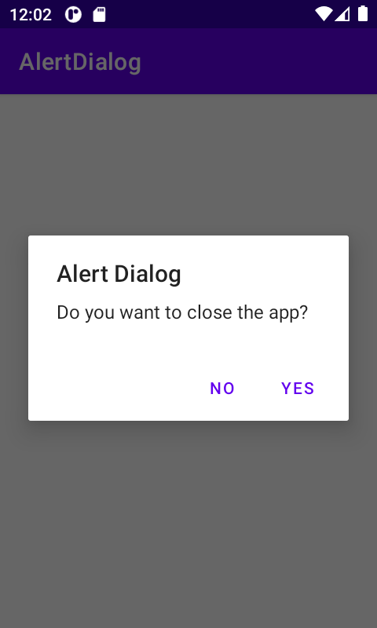

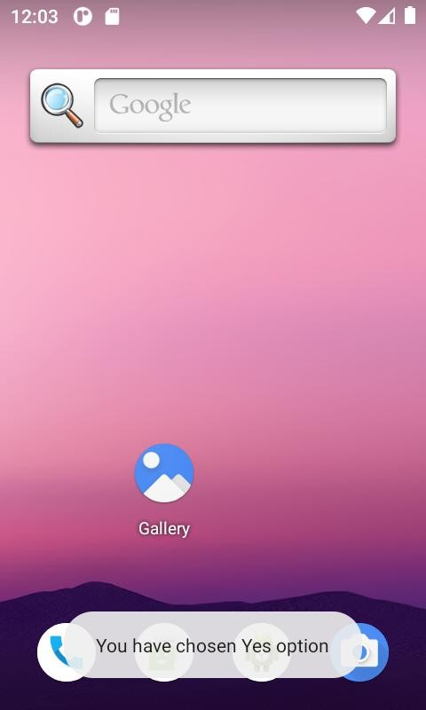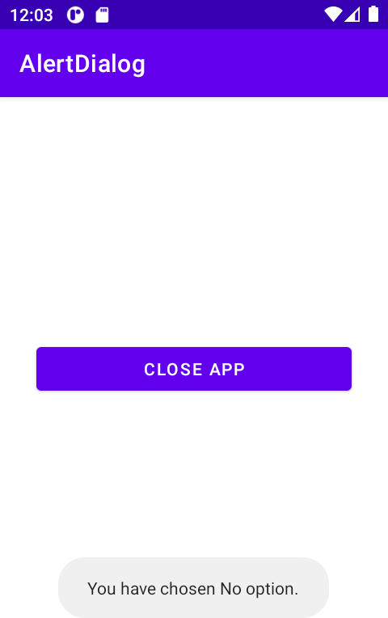

Experiment No: 10 Title: WaP to demonstrate Menus with their event handlers.
activity_main.xml
<?xml version="1.0" encoding="utf-8"?>
<LinearLayout xmlns:android="http://schemas.android.com/apk/res/android" xmlns:app="http://schemas.android.com/apk/res-auto" xmlns:tools="http://schemas.android.com/tools" android:layout_width="match_parent" android:layout_height="match_parent"
android:orientation="vertical" tools:context=".MainActivity">

<TextView
android:id="@+id/tvOption" android:layout_width="match_parent" android:layout_height="wrap_content" android:layout_marginTop="180dp" android:textSize="25sp" android:textStyle="bold" android:gravity="center" android:text="This is Option Menu" />

<TextView android:id="@+id/tvContext" android:layout_width="match_parent" android:layout_height="wrap_content" android:layout_marginTop="60dp" android:textStyle="bold" android:textSize="25sp" android:gravity="center"
android:text="This is context Menu" />

<Button
android:id="@+id/btnpopup" android:layout_width="250dp" android:layout_height="wrap_content" android:layout_gravity="center" android:layout_marginTop="130dp" android:text="tap to view Popup menu" android:onClick="showPopup"
/>
</LinearLayout>

MainActivity.java

package com.example.menusdemo; import androidx.annotation.NonNull;
import androidx.appcompat.app.AppCompatActivity; import android.os.Bundle;
import android.view.ContextMenu; import android.view.Menu;
import android.view.MenuItem; import android.view.View;
import android.widget.PopupMenu; import android.widget.TextView; import android.widget.Toast;

public class MainActivity extends AppCompatActivity implements PopupMenu.OnMenuItemClickListener {
TextView tvOption; @Override
protected void onCreate(Bundle savedInstanceState) { super.onCreate(savedInstanceState); setContentView(R.layout.activity_main);
TextView tvContext = findViewById(R.id.tvContext); registerForContextMenu(tvContext);
}
@Override
public boolean onCreateOptionsMenu(Menu menu) { getMenuInflater().inflate(R.menu.options_menu,menu); return true;
}
@Override
public boolean onOptionsItemSelected(@NonNull MenuItem item) { tvOption = findViewById(R.id.tvOption);
switch (item.getItemId()) { case R.id.Option1:
tvOption.setText("Profile"); return true;
case R.id.Option2: tvOption.setText("Download"); return true;
case R.id.Option3: tvOption.setText("Settings"); return true;
case R.id.Option4:

tvOption.setText("Exit"); return true;
}
return false;
}
@Override
public void onCreateContextMenu(ContextMenu menu, View v, ContextMenu.ContextMenuInfo menuInfo) {
super.onCreateContextMenu(menu, v, menuInfo); getMenuInflater().inflate(R.menu.context_menu,menu);
}
@Override
public boolean onContextItemSelected(@NonNull MenuItem item) { switch(item.getItemId()) {
case R.id.op1:
Toast.makeText(this, "Context 1 selected", Toast.LENGTH_SHORT).show(); return true;
case R.id.op2:
Toast.makeText(this, "Context 2 selected", Toast.LENGTH_SHORT).show(); return true;
default:
return super.onContextItemSelected(item);
}
}
public void showPopup(View v) { PopupMenu pop = new PopupMenu(this,v); pop.setOnMenuItemClickListener(this); pop.inflate(R.menu.popup_menu); pop.show();
}
@Override
public boolean onMenuItemClick(MenuItem menuItem) { switch (menuItem.getItemId()) {
case R.id.popupItem1:
Toast.makeText(this, "Cut Action", Toast.LENGTH_SHORT).show(); return true;
case R.id.popupItem2:
Toast.makeText(this, "Copy Action", Toast.LENGTH_SHORT).show(); return true;
}
return false; } }

- Options Menu Program – options_menu.xml
<?xml version="1.0" encoding="utf-8"?>
<menu xmlns:android="http://schemas.android.com/apk/res/android" xmlns:app="http://schemas.android.com/apk/res-auto">
<item
app:showAsAction="always" android:icon="@drawable/ic_baseline_more_vert_24" android:title="">
<menu>
<item
android:id="@+id/Option1" android:title="Profile"
android:icon="@drawable/ic_baseline_person_pin_24" app:showAsAction="never" />
<item
android:id="@+id/Option2" android:title="Download"
android:icon="@drawable/ic_baseline_arrow_downward_24" app:showAsAction="never" />
<item
android:id="@+id/Option3" android:title="Settings" android:icon="@drawable/ic_baseline_settings_24" app:showAsAction="never" />
<item
android:id="@+id/Option4" android:title="Exit"
android:icon="@drawable/ic_baseline_exit_to_app_24" app:showAsAction="never" />
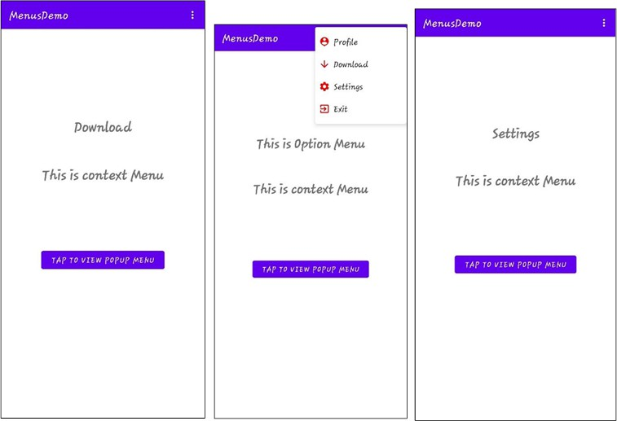
</menu>
</item>
</menu> Output –

- Context Menu

Program – context_menu.xml
<?xml version="1.0" encoding="utf-8"?>
<menu xmlns:android="http://schemas.android.com/apk/res/android">
<item
android:id="@+id/op1" android:title="op1" />
<item
android:id="@+id/op2" android:title="op2" />
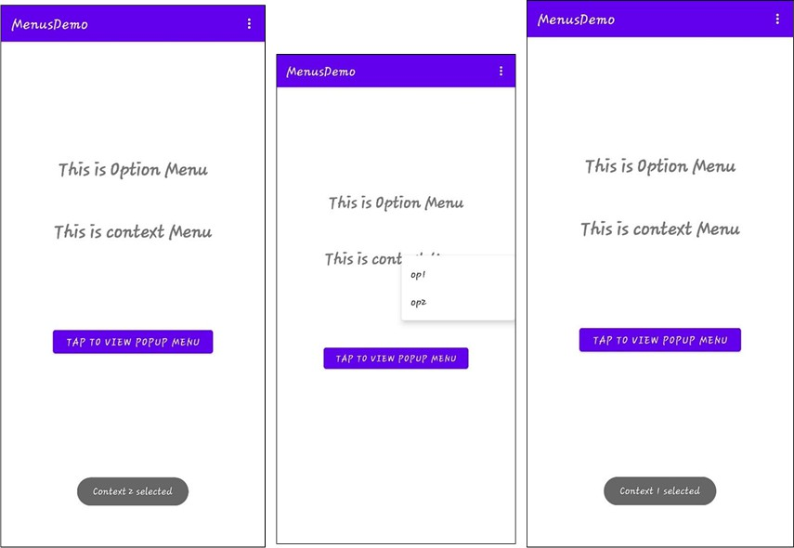
</menu> Output –

- Popup Menu

Program – popup_menu.xml
<?xml version="1.0" encoding="utf-8"?>
<menu xmlns:android="http://schemas.android.com/apk/res/android">

<item
android:id="@+id/popupItem1" android:title="Cut"/>
<item
android:id="@+id/popupItem2" android:title="Copy"/>
</menu>

Output -
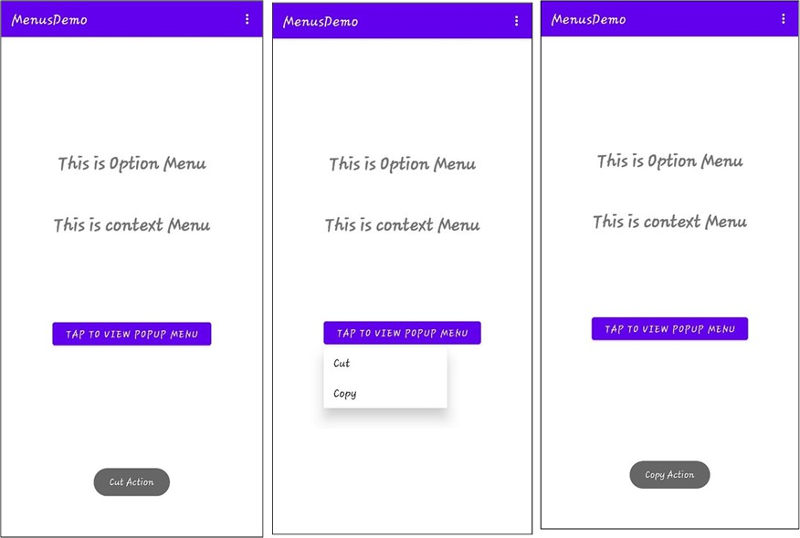

EXPERIMENT NO. – 11

Title – WaP to demonstrate Notification with their Actions. Program –
activity_main.xml
<?xml version="1.0" encoding="utf-8"?>
<androidx.constraintlayout.widget.ConstraintLayout xmlns:android="http://schemas.android.com/apk/res/android"
xmlns:app="http://schemas.android.com/apk/res-auto" xmlns:tools="http://schemas.android.com/tools" android:layout_width="match_parent" android:layout_height="match_parent" tools:context=".MainActivity">
<Button
android:id="@+id/NotificationBtn" android:layout_width="wrap_content" android:layout_height="wrap_content" android:text="Click to get Notification" app:layout_constraintBottom_toBottomOf="parent" app:layout_constraintEnd_toEndOf="parent" app:layout_constraintHorizontal_bias="0.5" app:layout_constraintStart_toStartOf="parent" app:layout_constraintTop_toTopOf="parent" />
</androidx.constraintlayout.widget.ConstraintLayout>

MainActivity.java
package com.example.notificationservice;

import androidx.appcompat.app.AppCompatActivity; import androidx.core.app.NotificationCompat;
import androidx.core.app.NotificationManagerCompat; import androidx.core.content.res.ResourcesCompat; import android.app.Notification;
import android.app.NotificationChannel; import android.app.NotificationManager; import android.graphics.Bitmap;
import android.graphics.drawable.BitmapDrawable; import android.graphics.drawable.Drawable;
import android.os.Build; import android.os.Bundle; import android.view.View;

import android.widget.Button;

public class MainActivity extends AppCompatActivity {

private static final String CHANNEL_ID = "My Channel"; private static final int NOTIFICATION_ID = 100; @Override
protected void onCreate(Bundle savedInstanceState) { super.onCreate(savedInstanceState); setContentView(R.layout.activity_main); Notification notification;
NotificationManager nm = (NotificationManager) getSystemService(NOTIFICATION_SERVICE);
if (android.os.Build.VERSION.SDK_INT >= android.os.Build.VERSION_CODES.O) { notification = new Notification.Builder(this)
.setSmallIcon(R.drawable.ic_baseline_data_usage_24)
.setContentText("New Message")
.setSubText("New message from Virat")
.setChannelId(CHANNEL_ID)
.build();
nm.createNotificationChannel(new NotificationChannel("My Channel","New Channel",NotificationManager.IMPORTANCE_HIGH));
}
else {
notification = new Notification.Builder(this)
.setSmallIcon(R.drawable.ic_baseline_data_usage_24)
.setContentText("New Message")
.setSubText("New message from Virat")
.build();
}
Button NotificationBtn = findViewById(R.id.NotificationBtn); NotificationBtn.setOnClickListener(new View.OnClickListener() {
@Override
public void onClick(View view) { nm.notify(NOTIFICATION_ID,notification);
}
});
}
}

Output -

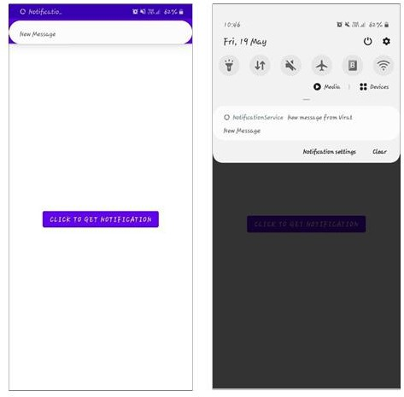

EXPERIMENT NO. – 12
Title – Write a program to study and use of SQLite database. Program :-
public class Database extends SQLiteOpenHelper {
private static final String dbname="signup.db";
public MyDatabase(@Nullable Context context) {
super(context, dbname, null, 1);
}
@Override
public void onCreate(SQLiteDatabase sqLiteDatabase) {
String query="create table users (id integer primary key autoincrement, name text, username text,passwod text)";
sqLiteDatabase.execSQL(query);
}
@Override
public void onUpgrade(SQLiteDatabase sqLiteDatabase, int i, int i1) {
}
}

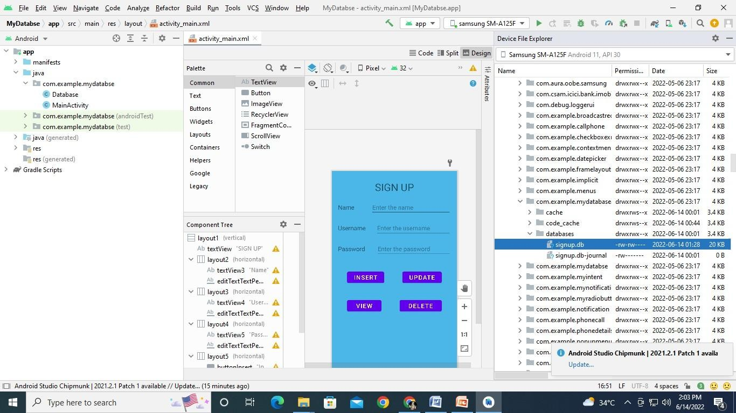

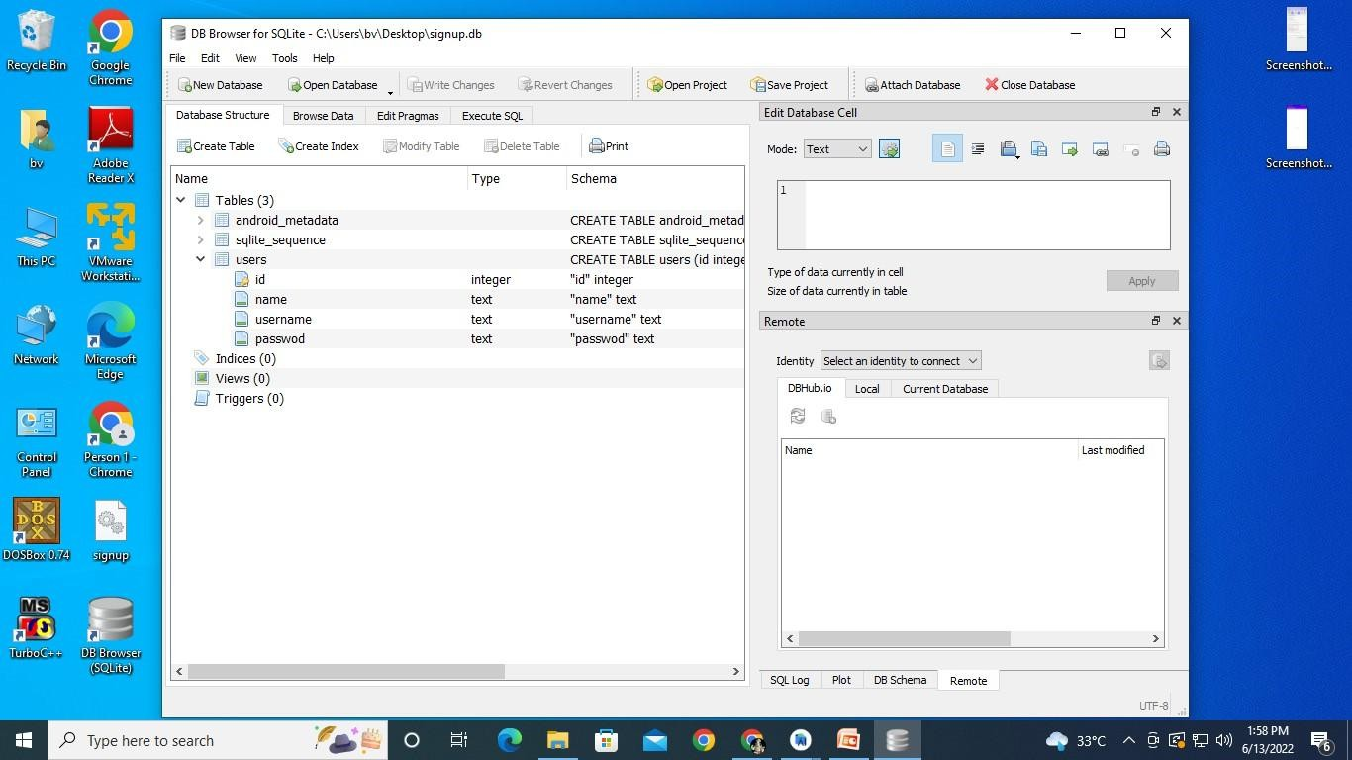

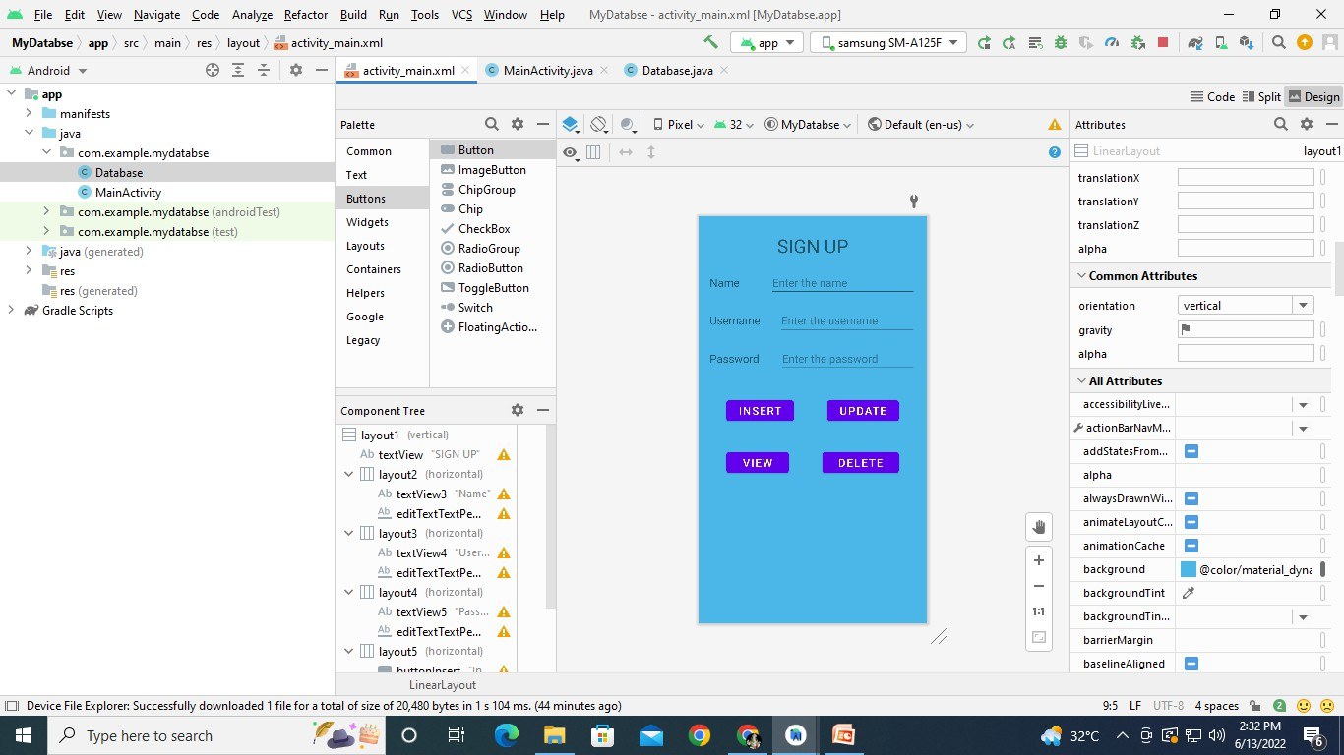

INSERT DATA

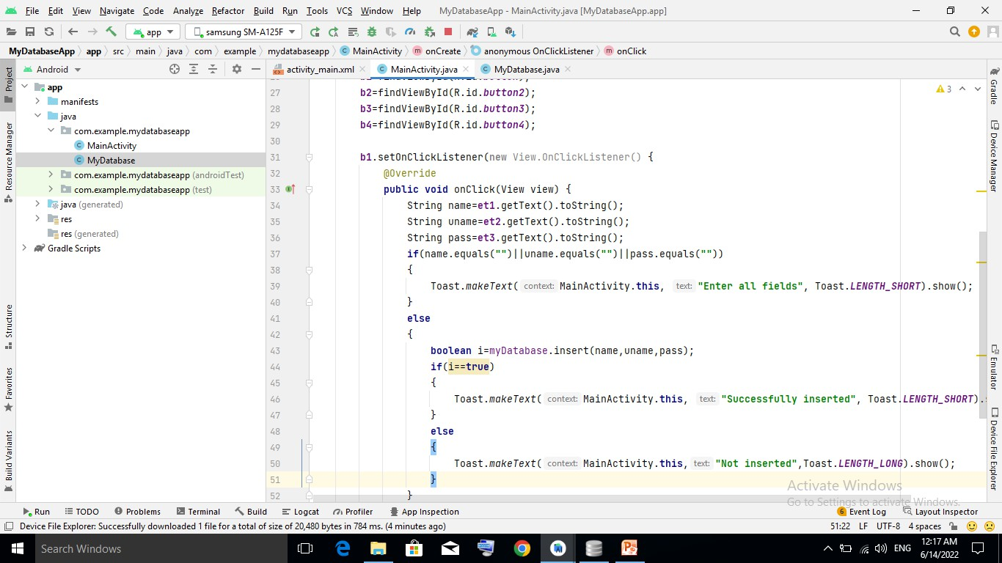

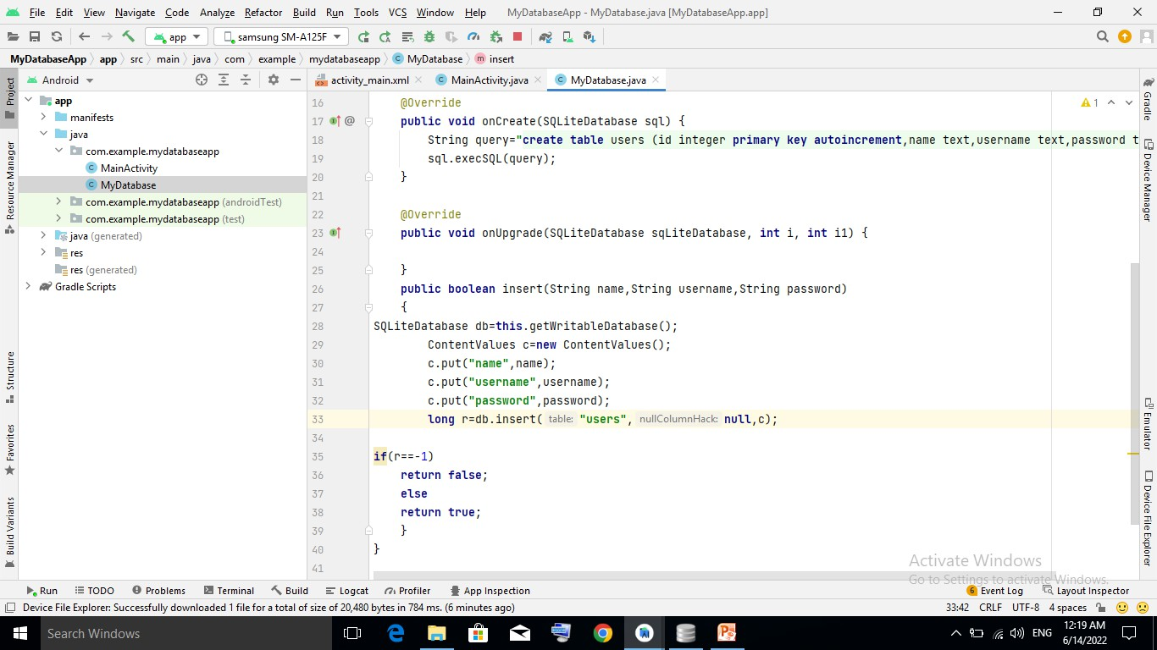

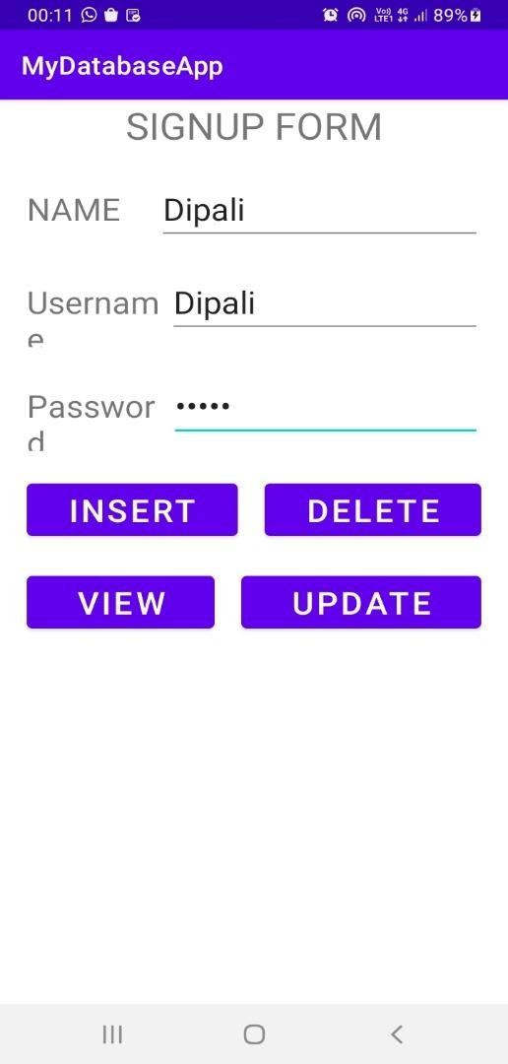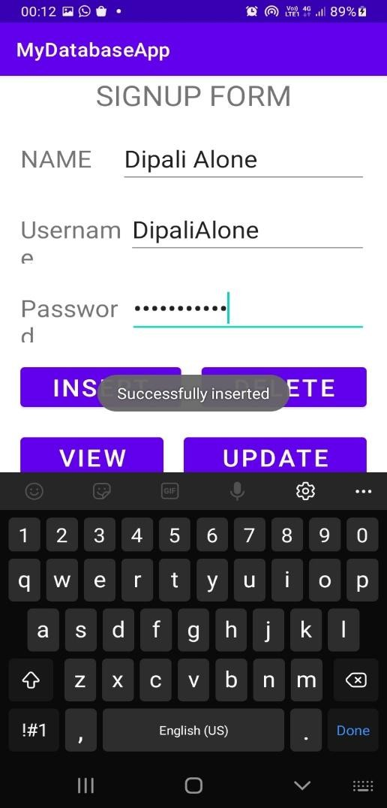

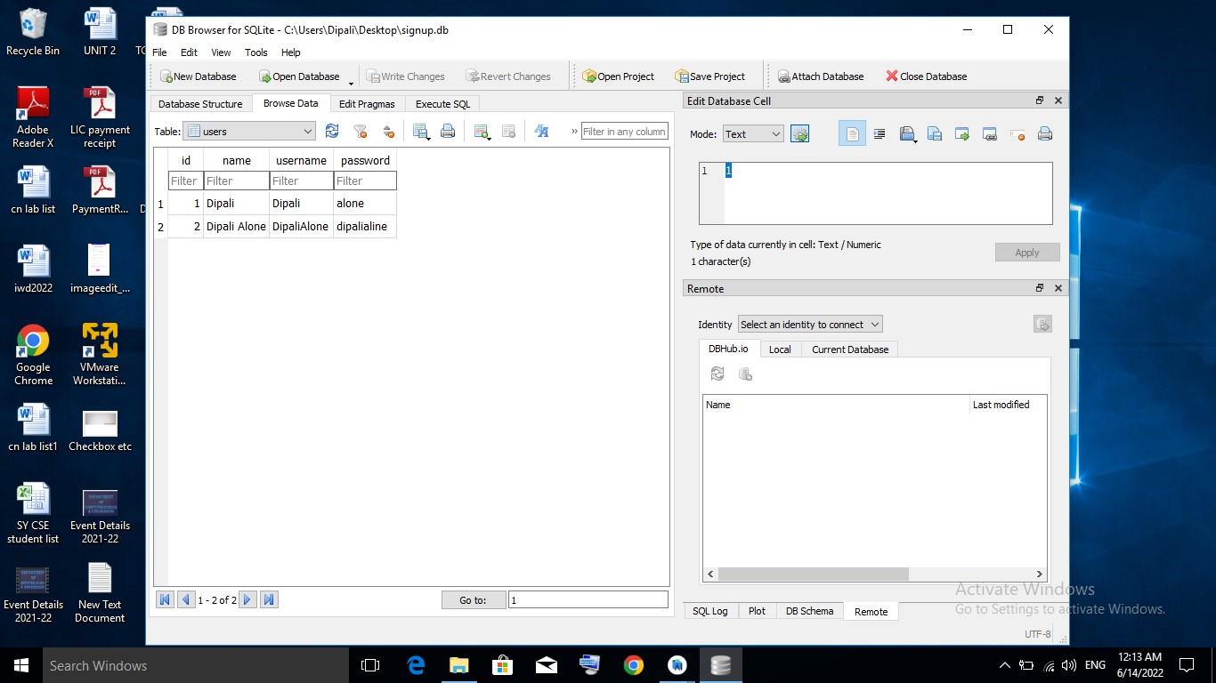

VIEW DATABASE
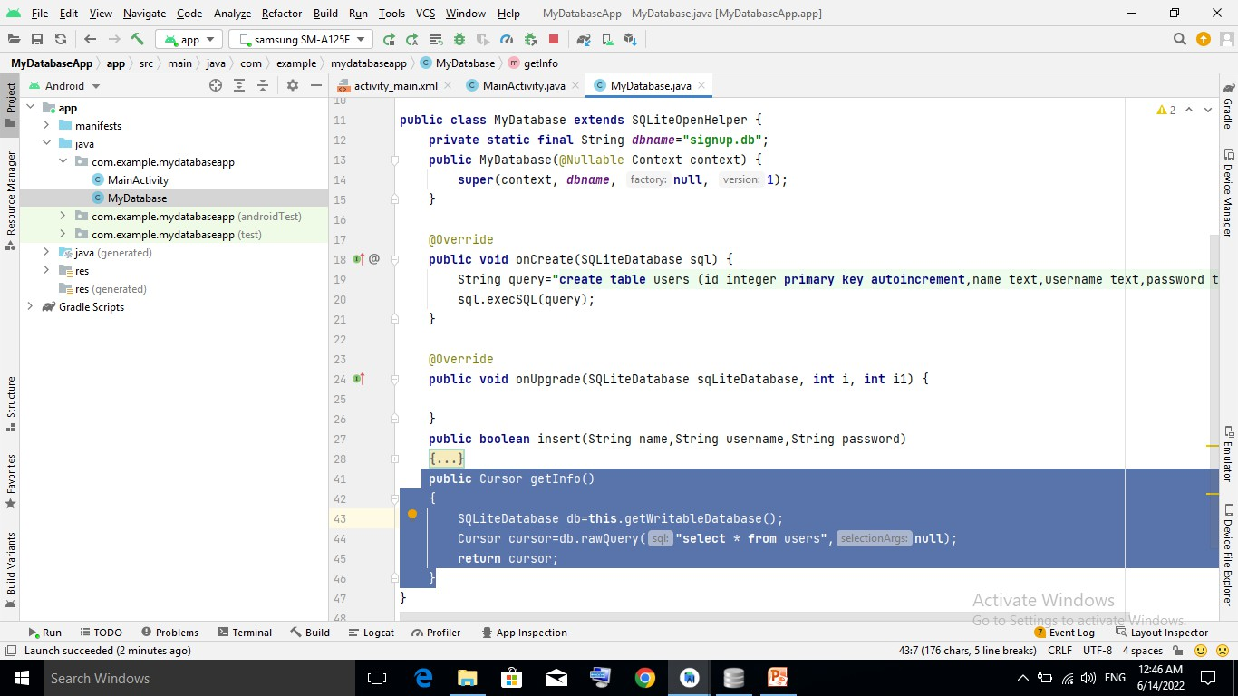
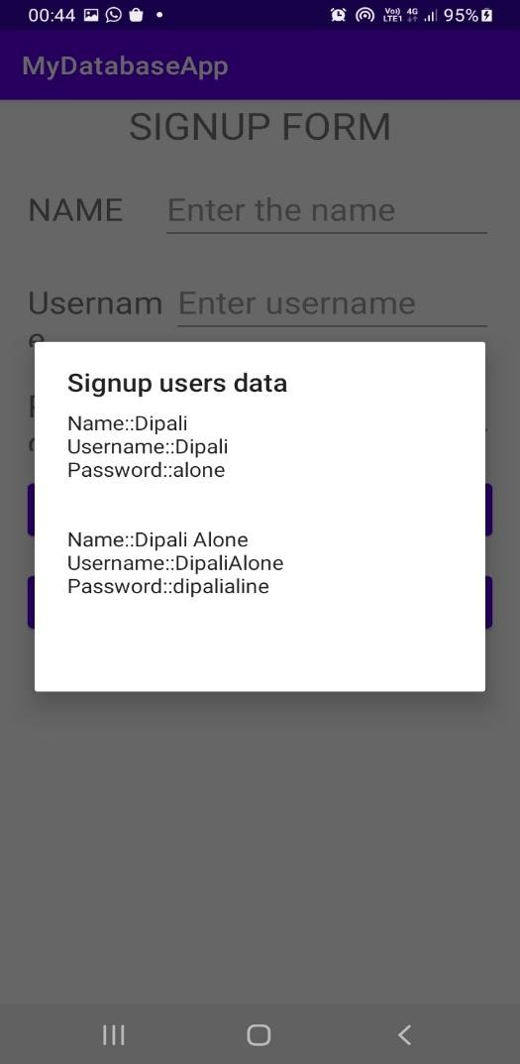

DELETE DATA
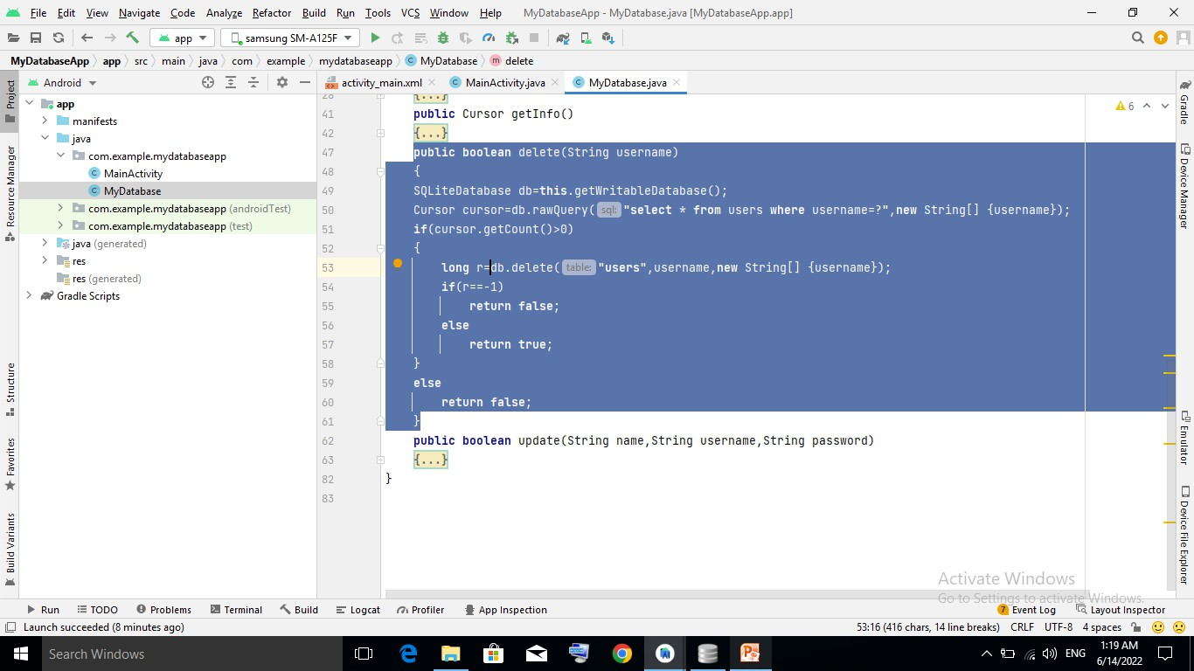
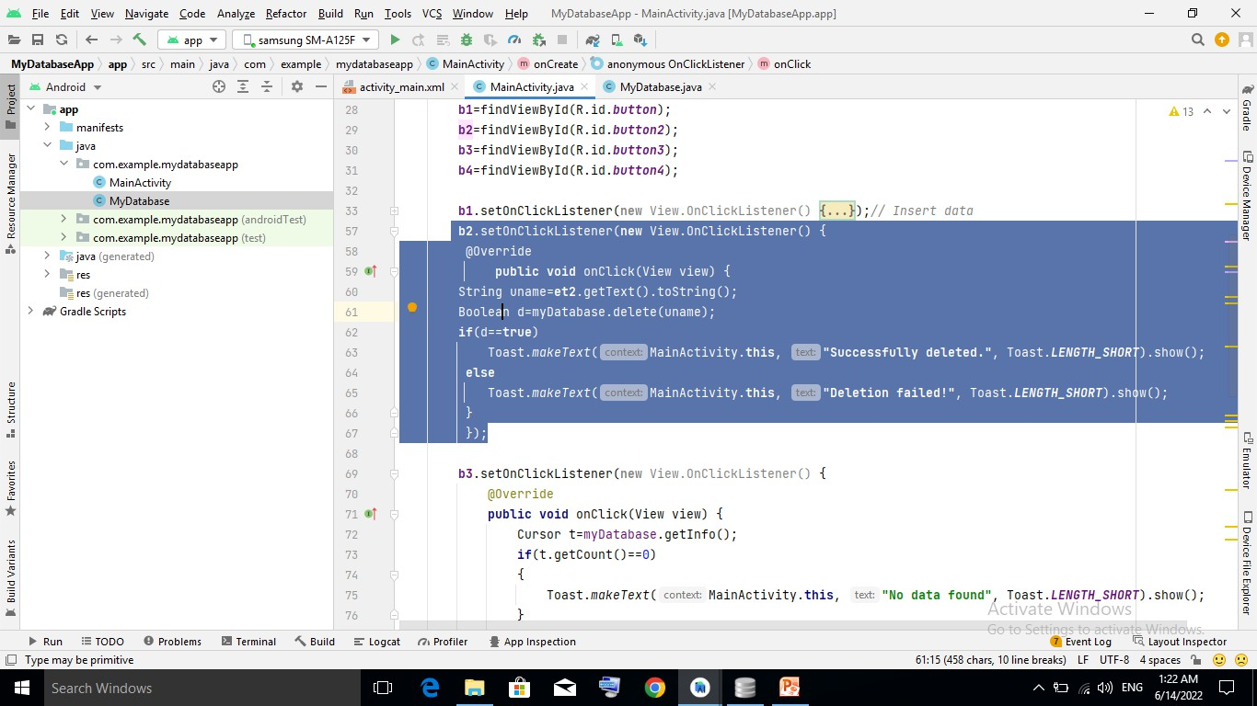

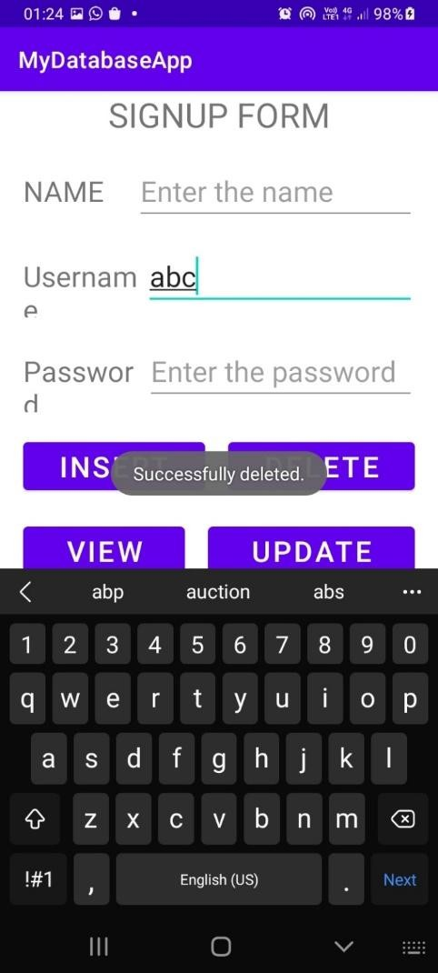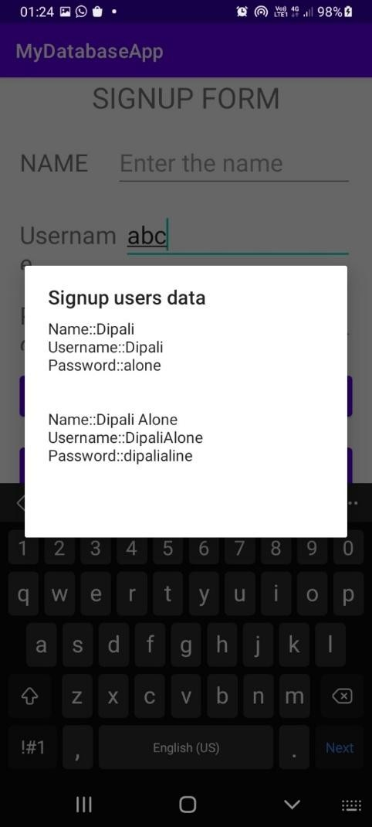
UPDATE
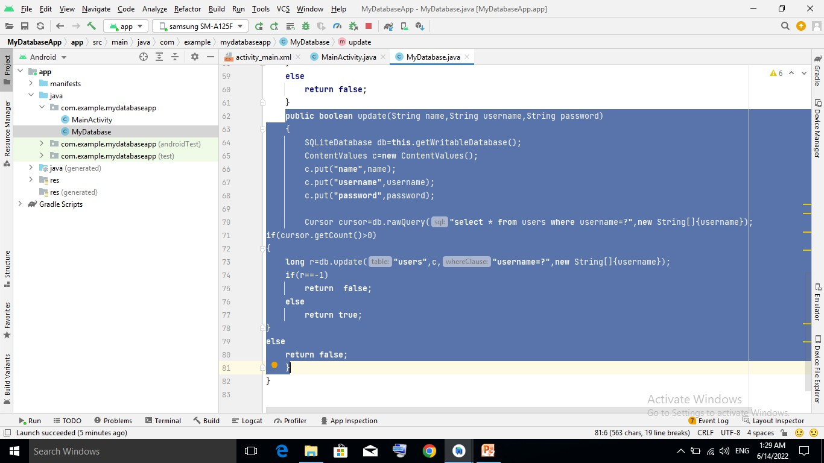

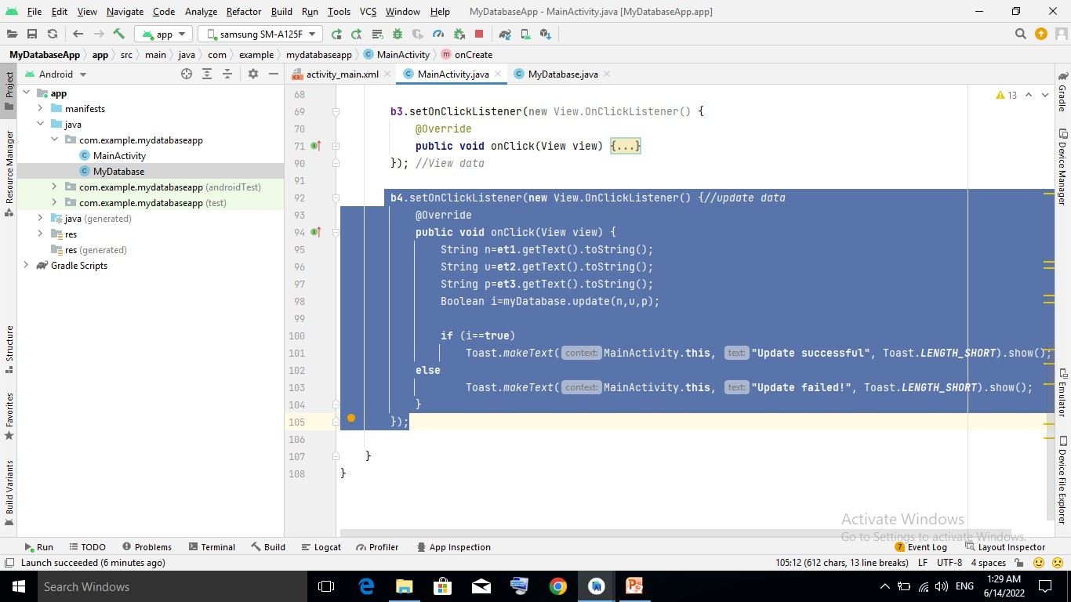

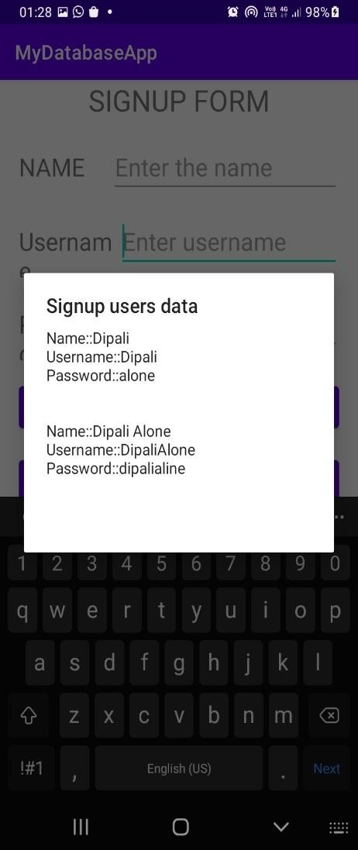
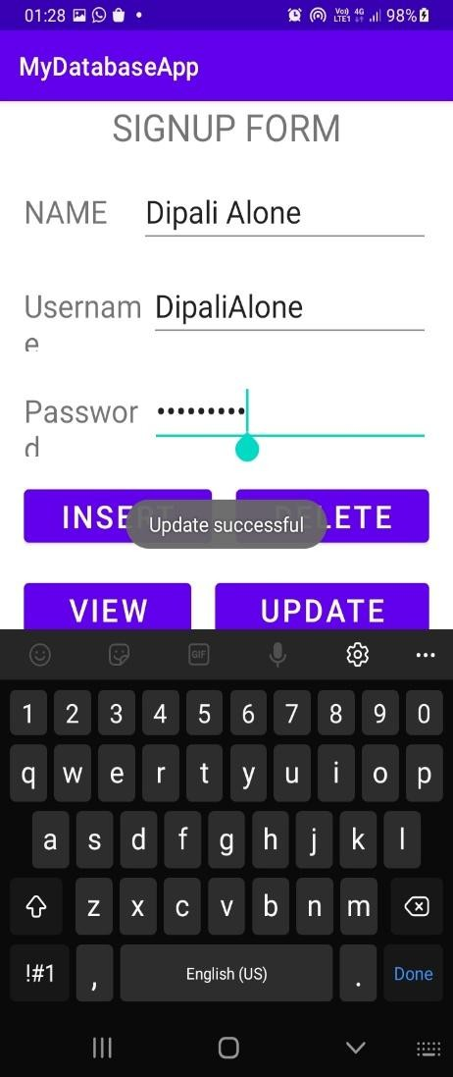
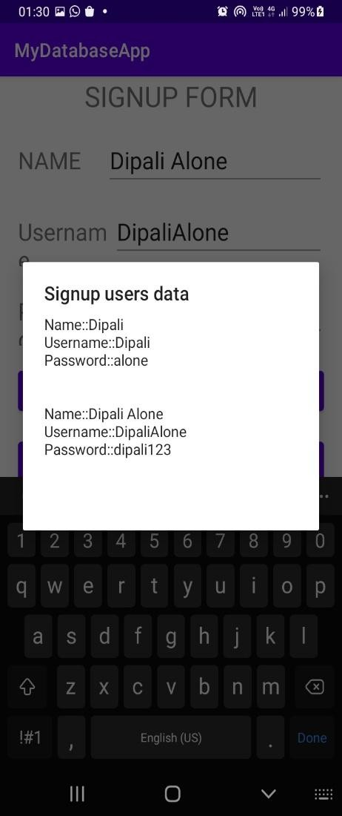

EXPERIMENT NO. – 14
Title – WaP to develop a native Calculator application. Program –
activity_main.xml
<?xml version="1.0" encoding="utf-8"?>
<LinearLayout xmlns:android="http://schemas.android.com/apk/res/android" android:orientation="vertical" android:layout_width="match_parent" android:layout_height="match_parent" android:layout_margin="20dp">
<LinearLayout android:id="@+id/linearLayout1" android:layout_width="match_parent" android:layout_height="wrap_content" android:layout_margin="20dp">

<EditText
android:id="@+id/editText1" android:layout_width="match_parent" android:layout_height="wrap_content" android:layout_weight="1" android:inputType="numberDecimal" android:textSize="20sp" />
<EditText
android:id="@+id/editText2" android:layout_width="match_parent" android:layout_height="wrap_content" android:layout_weight="1" android:inputType="numberDecimal" android:textSize="20sp" />
</LinearLayout>

<LinearLayout
android:id="@+id/linearLayout2" android:layout_width="match_parent" android:layout_height="wrap_content" android:layout_margin="20dp">
<Button
android:id="@+id/Add" android:layout_width="match_parent" android:layout_height="wrap_content"

android:layout_weight="1" android:text="+" android:textSize="30sp"/>
<Button
android:id="@+id/Sub" android:layout_width="match_parent" android:layout_height="wrap_content" android:layout_weight="1" android:text="-" android:textSize="30sp"/>
<Button
android:id="@+id/Mul" android:layout_width="match_parent" android:layout_height="wrap_content" android:layout_weight="1" android:text="*" android:textSize="30sp"/>
<Button
android:id="@+id/Div" android:layout_width="match_parent" android:layout_height="wrap_content" android:layout_weight="1" android:text="/" android:textSize="30sp"/>
</LinearLayout>

<TextView android:id="@+id/textView"
android:layout_width="match_parent" android:layout_height="wrap_content" android:layout_marginTop="50dp" android:text="Answer is" android:textSize="30sp" android:gravity="center"/>
</LinearLayout>

MainActivity.java
package com.example.calculatorapp; import android.os.Bundle;
import android.text.TextUtils; import android.view.View;
import android.view.View.OnClickListener; import android.widget.Button;

import android.widget.EditText; import android.widget.TextView;
import androidx.appcompat.app.AppCompatActivity;

public class MainActivity extends AppCompatActivity implements OnClickListener
{
//Defining the Views EditText Num1; EditText Num2; Button Add;
Button Sub; Button Mul; Button Div; TextView Result; @Override
public void onCreate(Bundle savedInstanceState)
{
super.onCreate(savedInstanceState); setContentView(R.layout.activity_main);
//Referring the Views
Num1 = (EditText) findViewById(R.id.editText1); Num2 = (EditText) findViewById(R.id.editText2); Add = (Button) findViewById(R.id.Add);
Sub = (Button) findViewById(R.id.Sub); Mul = (Button) findViewById(R.id.Mul); Div = (Button) findViewById(R.id.Div);
Result = (TextView) findViewById(R.id.textView);
// set a listener Add.setOnClickListener(this); Sub.setOnClickListener(this); Mul.setOnClickListener(this); Div.setOnClickListener(this);
}
@Override
public void onClick (View v)
{
float num1 = 0; float num2 = 0; float result = 0; String oper = "";
// check if the fields are empty
if (TextUtils.isEmpty(Num1.getText().toString()) || TextUtils.isEmpty(Num2.getText().toString()))

return;
// read EditText and fill variables with numbers num1 = Float.parseFloat(Num1.getText().toString()); num2 = Float.parseFloat(Num2.getText().toString());
// defines the button that has been clicked and performs the corresponding operation
// write operation into oper, we will use it later for output switch (v.getId())
{
case R.id.Add: oper = "+";
result = num1 + num2; break;
case R.id.Sub: oper = "-";
result = num1 - num2; break;
case R.id.Mul: oper = "*";
result = num1 * num2; break;
case R.id.Div: oper = "/";
result = num1 / num2; break;
default:
break;
}
// form the output line
Result.setText(num1 + " " + oper + " " + num2 + " = " + result);
}
}
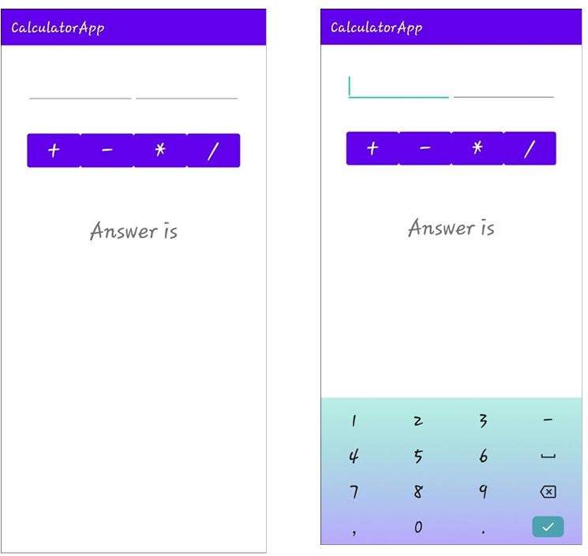
Output –

